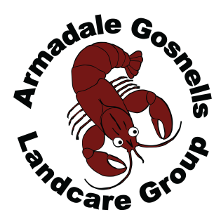

POSITION ADVERTISEMENT

Armadale Gosnells Landcare Group

Community Landcare Officer
An opportunity exists for a suitably qualified and experienced person to nurture and support community groups to develop and implement ecological restoration projects. The Armadale Gosnells Landcare Group is seeking to appoint a highly motivated person with excellent communication skills and experience in working with community groups on environmental rehabilitation projects.

This is a full-time, contract position ending on 30 June 2019. The position attracts a salary in the range of $64,389 - $68,861 plus superannuation and commuting use of a vehicle.

For further information and to obtain an information package, contact Narelle Mewburn on 0412 713 582. Applications addressing the selection criteria should be marked “Confidential” and must be received at PO Box 51, Armadale, 6992 or nmewburn@armadale.wa.gov.au no later than 4.00pm Wednesday, 23 May 2018.

